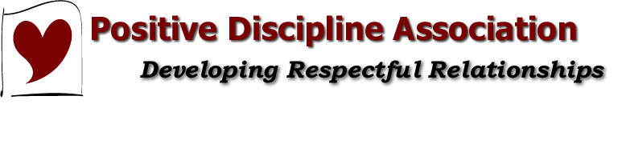
When Children Erupt...
Positive Discipline and the Explosive Child
with Steven Foster, CPDLT and
Joel Nixon, CPDT
Description:
In the wake of the ongoing violence in our public schools, there is a growing awareness that there are many children among us who are unable to manage feelings of anger, frustration, sadness and disappointment. Frequently exposed to high levels of traumatic experience, these children act out in ways that are both explosive and scary. How to help children who seem like they simply want to hurt and reject others is a challenge that, frankly, befuddles the adults who care for them.
This workshop explores how a Positive Discipline perspective, coupled with an awareness of the prevalence, impact and severity of trauma, can be used to respectfully connect with these children. They, too, can develop skills to help them achieve a sense of belonging and significance.
Due to the nature of the content of this workshop, participants should be aware that they may hear or see things that could cause emotional discomfort or offend some sensibilities.
Presenter's Bio:
Steven Foster, is a licensed clinical social worker who has been working with children and families in the Portland area for over thirty years. During that time he has worked in and directed and designed a number of treatment programs, always using a relationship-based approach, for young children and families struggling with emotional, social, and behavioral challenges. For the past sixteen years he has worked as an early childhood specialist at the Clackamas Education Service District outside Portland. There he has helped to create the array of services provided to children ages birth to five, and their families. A Positive Discipline parent educator since 2001, Steven is also a certified Positive Discipline trainer; training others to teach parenting classes. He is also a sought-after speaker on working with children and families with mental health concerns.

Joel Nixon LCSW, CPDT has more than 20 years helping children, families and teachers overcome life’s challenges. He is a Licensed Clinical Social Worker, a Certified Positive Discipline Trainer and a Master Trainer with the Oregon Center for Career Development in Childhood Care and Education. In addition to being the founder and clinical director of the Child & Family Wellness Project, Joel is also an Early Childhood and Behavior Specialist for a local Early Childhood Special Education program.

Contact Information:
Name: Steven Foster
Email Address: sfos54@msn.com
Contact Information:
Name: Deborah Owen-Sohocki
Email Address: joelnixon.cfwp@gmail.com

