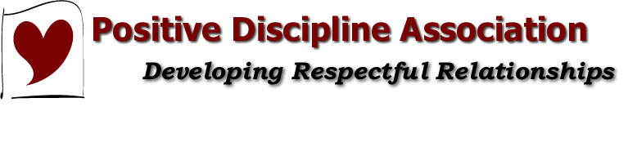
Two Generations of Positive Discipline:
Jane Nelsen and Her Grown Children Tell All!
with Dr. Jane Nelsen, PDA Co-Founder,
Brad Ainge and Mary Tamborski, CPDPE

Description:
Jane Nelsen and two of her seven children, Brad Ainge and Mary Nelsen Tamborski, share their experiences with two generations of Positive Discipline. Each will share a few of their favorite Positive Discipline tools—and their least favorites. (Learn why Brad does not like “Put Them in the Same Boat”.)
Presenter's Bio:
Jane Nelsen is the mother of 7, grandmother of 22, and great grandmother of 5, wife of Barry Nelsen for 44 years. She is also the author and co-author of many Positive Discipline books, a California licensed MFT, and received her Ed.D. in Educational Psychology from the University of San Francisco.
Brad Ainge is the father of three children. Full-time single dad, wannabe housewife, and part-time golf addict. Hobbies include: laundry, dish washing, animal control, and referee for the occasional "He started it!" "No, she started it!" debate."
Mary Tamborski is the mother of 3 boys. Co-author of the Keeping the Joy In Marriage Tool Cards and eBook. Certified Positive Discipline Parent Educator and Parenting Coach.
Contact Information:
Name: Jane Nelsen
Email Address: jane@positivediscipline.com
School/Organization: Author/Speaker
Name: Brad Ainge
Email Address: brad.ainge@gmail.com
Organization: CEO of www.positivediscipline.com

Name: Mary Nelsen Tamborski
Email Address: Mary@positivediscipline.com
Organization: Marriage and Family Therapist Intern with Roots and Wing

